# **RONDE MUST DE CARTIER WATCH**

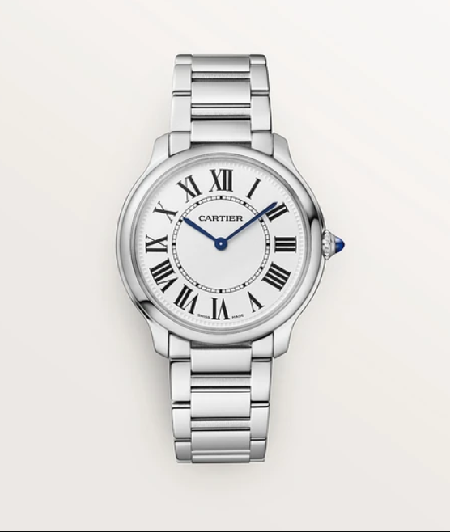

Product Details:

Ronde Must de Cartier watch, 36 mm, high autonomy quartz movement (approx. 8 years).

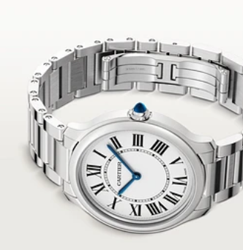Steel case, beaded crown set with a synthetic cabochon-shaped spinel, sandblasted silvered dial, blued-steel sword-shaped hands, sapphire crystal, steel strap fitted with an interchangeability system.

Thickness: 7.89 mm. Water-resistant to 3 bar (approx. 30 metres).